Question: Create a well structured report on Version Control Systems.
An Overview of Version Control Systems (VCS)
Version control, also known as source control, is the practice of tracking and managing changes to software code. Version control systems record changes made to files. They store revisions in a structured way. They allow teams to see what changed, when it changed, and who changed it. They prevent confusion by keeping a single source of truth. They also allow developers to revert to earlier versions when errors or conflicts occur. The figure below shows how version control works.
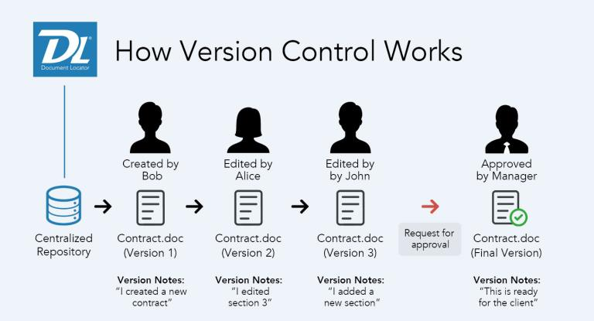

Components of Version Control Systems (VCS)
- Repository Management: At the core of any version control system is the repository. This centralized storage location houses all project files, their revision history, and associated metadata.
- Branching and Merging: Branching and merging are fundamental features of modern version control systems. These capabilities allow developers to work on different aspects of a project simultaneously without interfering with each other’s work. Branching enables the creation of separate lines of development, perfect for working on new features, bug fixes, or experimental changes. Merging, on the other hand, allows developers to combine changes from different branches back into the main codebase.
- Commit History and Logging: A version control system should provide a comprehensive commit history, allowing developers to track changes made to the codebase over time. This feature is crucial for understanding the evolution of a project, identifying when specific changes were introduced, and troubleshooting issues.
- Collaboration and Code Review: Version control systems should facilitate seamless collaboration among team members. This includes features that support code review processes, allowing developers to provide feedback, suggest improvements, and ensure code quality before changes are merged into the main codebase.
- Tagging and Release Management: Version control systems should provide features for tagging specific points in the project’s history, typically used to mark release versions. This functionality is crucial for managing software releases and maintaining a clear record of different versions. Others include:
- Remote Repository Interaction
- Stashing and Workspace Management
- Integration and Extensibility
Types of Version Control Systems
We can broadly divide VCS into 3 generations:
- Local Version Control System: A local version control system is a database situated on your local computer where every file change is stored as a patch. Each patch set contains only the changes made to the file since its last version. To view what the file looked like at any given moment, it’s necessary to aggregate all the relevant patches to the file up to that specific moment.
The main drawback with this system is that everything is stored locally. If anything were to happen to the local database, all the patches would be lost. Similarly, if anything were to
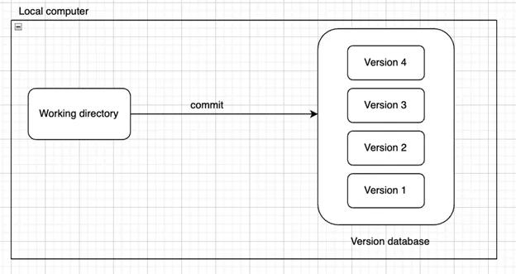
happen to a single version, all the changes made after that version would be lost. Examples of Local VCS: SCCS, RCS

- Centralized Version Control System: A centralized version control system has a single server containing all file versions. This setup enables multiple clients to simultaneously access files on the server, pulling them to their local computer or pushing them onto the server from their local computer. This way, everyone typically knows what each team member is working on. Administrators maintain control over user permissions.
This structure facilitates seamless collaboration among developers or a team. However, a significant drawback is that everything is stored on the centralized server. If something were to happen to that server, users wouldn’t be able to save their versioned changes, pull files, or collaborate. Similar to Local Version Control, if the central database were to become corrupted without proper backups, the entire project history could be lost, except for individual snapshots stored on users’ local machines. Examples of Centralized VCS: CVS, Perforce, Subversion
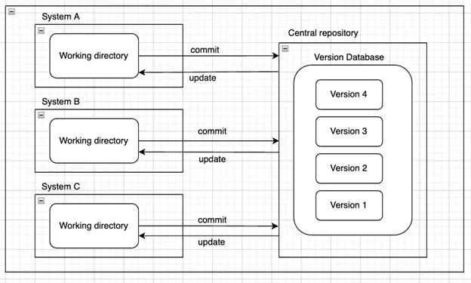

- Distributed Version Control System: In distributed version control systems, clients don’t merely check out the latest snapshot of files from the server; instead, they fully mirror the repository, encompassing its entire history. Consequently, each collaborator in a project possesses a local copy of the entire project, constituting their own local database with a complete history. In this model, if the server becomes unavailable or fails, any of the client repositories can transmit a copy of the project’s version to another client or restore it to the server when it becomes accessible. It suffices for one client to contain a correct copy, which can then be easily distributed further.
References:
https://ones.com/blog/essential-features-version-control-system-developers/
https://medium.com/@pm74367/types-of-vcs-version-control-system-f7af5594bd04
https://www.atlassian.com/git/tutorials/what-is-version-control

